GCP Assignment 2

- Launch instance with only private ip and configure NAT so instance can access Internet. (Need to use network tags)

- Create VPC with custom subnet:
- Custom subnets
- Single subnet with range 192.168.1.0/24 in region us-central-1

- Create firewall for bastion host:
- Network should be the created VPC
- Direction INGRESS
- priority 1000
- action ALLOW
- rules tcp:22
- source-ranges 59.152.53.203/32 (Allows only ssh from your terminal!)
- target-tags bastion-host

- Create firewall for private instance:
- Network should be the VPC just created
- Direction INGRESS
- priority 1000
- action ALLOW
- rules tcp:22
- source-tags bastion-host
- target-tags allow-ssh-private

- Launch bastion host instance:
- region us-central1
- zone us-central1-c
- service account should have following permissions:
- compute.instances.setMetadata
- compute.projects.setCommonInstanceMetadata
- compute.projects.get
- compute.instances.get
-In Management, security, disks, networking, sole tenancy under networking tab:
network-tag bastion-host
-Edit the existing network interface:
Network should be the created VPC
Subnetwork should be the created subnet

- Launch private instance:
- region us-central1
- zone us-central1-c
-In Management, security, disks, networking, sole tenancy under networking tab:
network-tag allow-ssh-private
-Edit the existing network interface:
Network should be the created VPC
-Subnetwork should be the created subnet
- External IP None

- On local terminal:
local-terminal:~$ gcloud beta compute --project "pe-training" ssh --zone "us-central1-c" "<bastion-host-instance-name>"

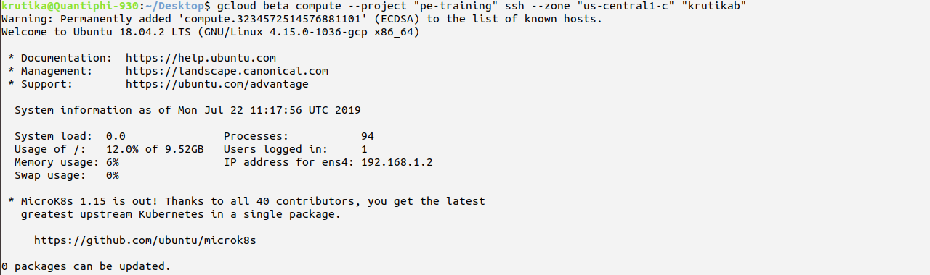

On bastion host:
bastion-host:~$ gcloud beta compute --project "pe-training" ssh --zone "us-central1-c" "<private-instance-name>" --internal-ip

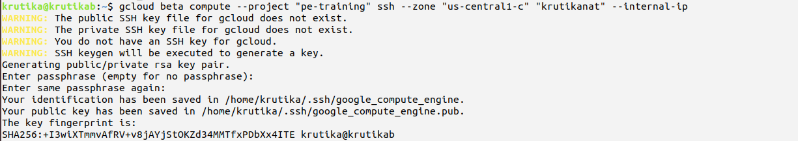
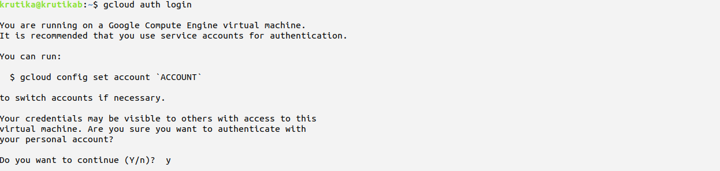
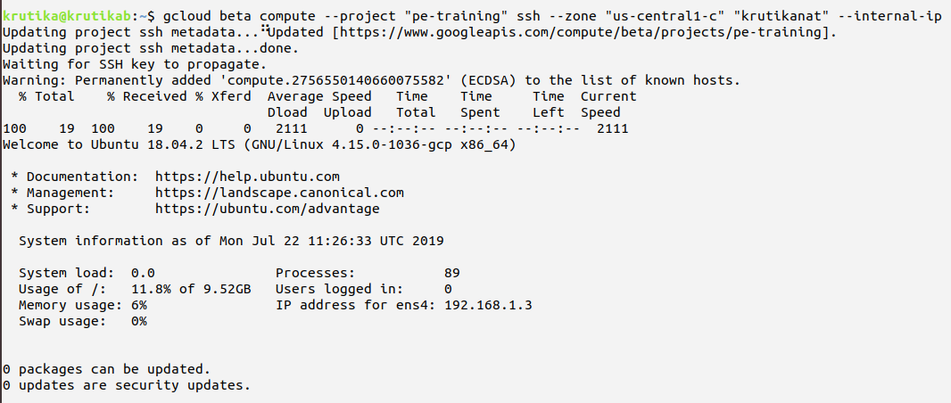
- Check for internet access:
private-intance:~$ curl example.com (Should timeout)

- Set up Cloud NAT
1. Go to the Cloud NAT page in the Google Cloud Platform Console.
2. Go to the Cloud NAT page
3. Click Get started or Create NAT gateway.
4. Enter a Gateway name.
5. Set the VPC network to above VPC.
6. Set the Region to us-central1.
7. Under Cloud Router, select Create new router.
- Enter a Name for NAT router.
- Click Create.
8. Click Create.

- Check for internet access:
private-intance:~$ curl example.com (Should show HTML DOM)

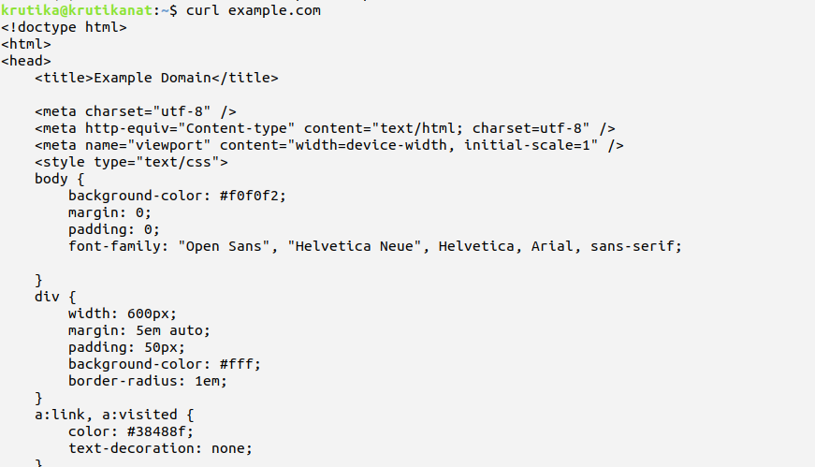

- Configure Stackdriver monitoring on an AWS EC2 instance using the monitoring agent. Also explore how to monitor both AWS and GCP projects at a single place.

- Creating a single workspace for GCP and AWS projects
- Create a GCP project (Best practice is to create a separate project for monitoring multiple projects)
- In the GCP Console, go to New Project.
- In the Project Name field, enter the name you want.
- Click Create.
- Create a Workspace in the monitoring project
- Go to GCP Console
- In the menu bar, click the drop-down list next to the Google Cloud Platform and select your GCP project for monitoring.Click Monitoring.
- If the Add your project to a Workspace dialog is displayed, create a new Workspace by selecting your GCP project under New Workspace and then clicking Add.
- The Add your project to a Workspace dialog is displayed only when you have at least one existing Workspace available to you.
- The Workspaces listed under Existing Workspace are Workspaces you've created or Workspaces for GCP projects where you have editorial permission. Using this dialog, you can choose between creating a new Workspace and adding your project to an
existing Workspace.
- Next, Monitoring creates a new Workspace and adds your GCP project to the Workspace.
During Workspace creation, Monitoring proceeds through the following phases:
- Building your Workspace
- Enabling Stackdriver APIs
- We're still collecting data for your new Workspace
- These phases might take several minutes to complete. When this process is complete, the Stackdriver Monitoring console
displays the Monitoring Overview pane and a welcome message
- You can add your GCP projects to the workspace

- Steps to add an AWS account to the workspace

Get your account and external IDs
- Go to the Stackdriver Monitoring console
- Next to the Stackdriver logo in the title bar, a Workspace name is displayed. If this isn't your monitoring project,
click on the drop-down list and select it.
- At the bottom of the Workspace menu, click Workspace Settings.
- Under Settings, click Monitored accounts.
- Click Add AWS account.
- Record the Account ID and External ID. You need this data to create your AWS Role.
- Click Cancel. You add your AWS account after you create your AWS role.

- Creating an AWS role
- Log into your AWS IAM console and click Roles in the left-side menu.
Click Create New Role and do the following:
- For the Role type, select Another AWS account.
- In the Account ID field, enter the account ID provided by Stackdriver.
- Select the Require external ID checkbox.
- In the External ID field, enter the external ID provided by Stackdriver.
- Don't select Require MFA.
- Click Next: Permissions.
- From the Policy name drop-down list, select ReadOnlyAccess:
- Click Next: Review and fill in or verify the following information:
- In the Role name field, enter a name such as GoogleStackdriver.
- In the Role description field, enter anything you wish.
- In the Trusted entities field, verify it's the Account ID you entered earlier.
- In the Policies field, verify the value is ReadOnlyAccess.
- In the AWS IAM page, click Create Role.
- On the Summary page, copy the Role ARN string so that you can give it to Stackdriver.
- If you don't see the summary, click the name of your role (for example, GoogleStackdriver) in the list of AWS roles.

- Connecting an AWS Account
- Go to the Stackdriver Monitoring console
- From the Workspace menu at the top of the page, select your Workspace.
- At the bottom of the Workspace menu, click Workspace Settings.
- Under Settings, click Monitored accounts.
- Click Add AWS account. Enter the Account ID and External ID from when you created a Workspace.
- Enter the following information in the form:
- In the Role ARN field, enter your Role ARN from Creating an AWS role or follow the instructions on
the Add AWS account page to create the role.
- In the Description of account field, enter a short description of your AWS account. The first word
or two is used to create a new project ID.
- Click Add AWS account. In a moment, the connection is confirmed.

- AWS connector projects
- When you connect to an AWS account, Monitoring creates an AWS connector project for you.
- The Monitored accounts page in your Workspace settings now includes the ID for this project:
- Your AWS account description [YOUR_AWS_ACCOUNT_NUMBER]
- Connected to [CONNECTOR_PROJECT_ID]
Where:
- [YOUR_AWS_ACCOUNT_NUMBER] represents the account number for your AWS account.
- [CONNECTOR_PROJECT_ID] represents the connector project where you receive logs and metrics from your AWS account
and where you set up authorization for agents and other AWS applications that need to access GCP.
- The connector project's ID always begins with aws-, and the project's name always begins with AWS Link

- Authorizing AWS applications
- You must perform the following steps if you do any of the following:
- Run any of the Stackdriver agents on AWS VM instances for advanced monitoring.
- Use any GCP services from AWS applications.
- To authorize applications running on AWS to access GCP services, you give them access to a GCP service account
that has suitable GCP IAM roles.
- A single service account can authorize multiple AWS VM instances and applications in the same AWS account, or you
can create multiple service accounts.

- Create a service account
- To create the service account, go to the IAM & Admin > Service accounts page for your connector project:
- Go to the Service Accounts page
- Select the AWS connector project (named AWS Link...) for your AWS account.
- Your connector project likely has no service accounts, so you are asked to create one.
- Click Create service account and enter the following information:
- In the Service account name field, enter Stackdriver agent authorization.
- In the Role field, add both of the following values:
- Monitoring > Monitoring Metric Writer
- Logging > Logs Writer
- Select the Furnish a new private key checkbox.
- For Key type, click JSON.
- Clear the Enable G Suite Domain-wide Delegation checkbox.
- Create service account
- Click Create. The service account's private-key file is downloaded to your workstation with a name
such as Downloads/[PROJECT_NAME]-[KEY_ID].json.
Where:
- [PROJECT_NAME] represents the name of your GCP project.
- [KEY_ID] represents the generated private key.
- To make the following instructions simpler, save the location of the credentials file in the variable CREDS
on your workstation: CREDS="Downloads/[PROJECT_NAME]-[KEY_ID].json"

- Add a service account to a VM instance
- From your workstation, copy the Stackdriver private-key credentials file to your AWS EC2 instance and save it in
a file named temp.json. In the scp command, specify the path to key.pem, your AWS SSH key pair file, and provide
your AWS credentials:
KEY="/path/to/key.pem"
scp -i "$KEY" "$CREDS" AWS_USERNAME@AWS_HOSTNAME:temp.json
- On your EC2 instance, move the credentials to /etc/google/auth/application_default_credentials.json:
GOOGLE_APPLICATION_CREDENTIALS="/etc/google/auth/application_default_credentials.json"
sudo mkdir -p $(dirname "$GOOGLE_APPLICATION_CREDENTIALS")
sudo mv "$HOME/temp.json" "$GOOGLE_APPLICATION_CREDENTIALS"
- Note: /etc/google/auth/application_default_credentials.json is where the monitoring and logging agents look for
the private key.
- (Optional): Restrict access to the private-key credentials for the service account. For example:
sudo chown root:root "$GOOGLE_APPLICATION_CREDENTIALS"
sudo chmod 0400 "$GOOGLE_APPLICATION_CREDENTIALS"
- Make sure the environment variable GOOGLE_APPLICATION_CREDENTIALS is visible to the agents and other applications
that are authorized to use GCP. The environment variable name is understood by the standard GCP client libraries.

- Install the Stackdriver Monitoring and Logging agents
- Run the following commands on your EC2 instance:
curl -sSO https://dl.google.com/cloudagents/install-monitoring-agent.sh
sudo bash install-monitoring-agent.sh
curl -sSO https://dl.google.com/cloudagents/install-logging-agent.sh
sudo bash install-logging-agent.sh --structured
- Verify that the agents are running.
ps ax | grep fluentd
ps ax | grep collectd
The expected output should be similar to the following:
[PROCESS_ID] ? Sl 0:00 /opt/google-fluentd/embedded/bin/ruby /usr/sbin/google-fluentd ...
[PROCESS_ID] ? Ssl 0:00 /opt/stackdriver/collectd/sbin/stackdriver-collectd ...

- Create an instance with Linux OS of your choice. The instance should run apache server that displays your name when the webpage is accessed via a browser. The task should be completed without accessing the instance via SSH. Stop the instance (using CLI) and restart the instance (again using CLI) and check again if the apache server is running. View the log file of the server startup.

- Creating instance that run apache server
- Goto VM instance -> create new instance
- Enter name, region, m/c configuration, in firewall-> allow http traffic
- In management enter the starter script
#!/bin/bash
apt-get update -y
apt-get install apache2 -y
mv /var/www/html/index.html /var/www/html/index.php
cat <<EOF> /var/www/html/index.php
<html>
<body>krutika</body>
</html>EOF

- Create the instance
- Enter the instance external ip in the browser -> it will show the webpage.
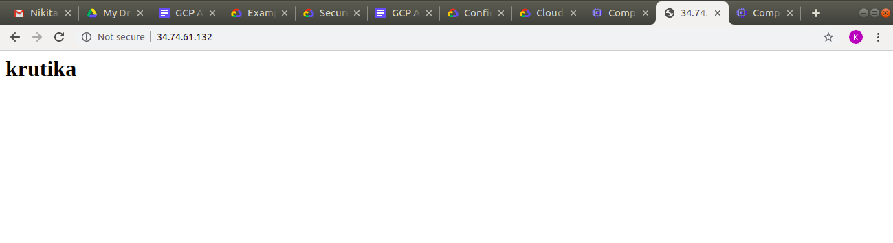
- Stop the instance (using CLI) and restart the instance (again using CLI)

krutika@Quantiphi-930:~$ gcloud compute instances stop krutika
Stopping instance(s) krutika...done.
Updated [https://www.googleapis.com/compute/v1/projects/pe-training/zones/us-east1-b/instances/krutika].

krutika@Quantiphi-930:~$ gcloud compute instances start krutika
Starting instance(s) krutika...done.
Updated [https://www.googleapis.com/compute/v1/projects/pe-training/zones/us-east1-b/instances/krutika].

- View logs of instance
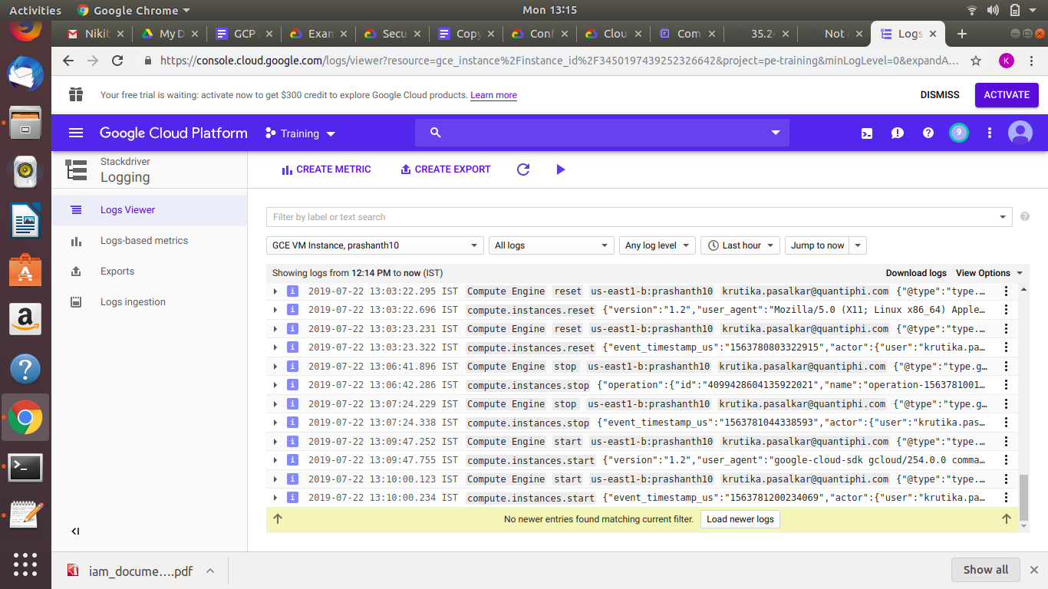

- Create a scalable serverless architecture to detect objects from the images immediately after being uploaded to a GCS bucket. The extracted information about the objects should be logged [optional: stored to datastore database]. The designed architecture should also have error handling.

Lambda function
- Go to cloud function -> create function
- Give name to function, in trigger select cloud storage
- Event type create
- runtime -> python and enter the below code in main.py

def detect_object(data, context):
try:
from google.cloud import storage, vision
#from wand.image import Image
storage_client = storage.Client()
client = vision.ImageAnnotatorClient()
file_data = data
file_name = file_data['name']
bucket_name = file_data['bucket']
blob = storage_client.bucket(bucket_name).get_blob(file_name)
blob_uri = f'gs://{bucket_name}/{file_name}'
print(blob_uri)
image = vision.types.Image()
image.source.image_uri=blob_uri
objects = client.object_localization(image=image).localized_object_annotations
print('Number of objects found: {}'.format(len(objects)))
for object_ in objects:
print('\n{} (confidence: {})'.format(object_.name, object_.score))
for label in labels:
label_list.append(label.description)
client_datastore=datastore.Client()
task = datastore.Entity(client_datastore.key('krutika'))
task.update({
'labels': label_list,
})
client_datastore.put(task)
except FileNotAnImageException as fnaie:
print(fnaie)
except Exception as e:
print(e)

- Enter below lines in requirements.txt
google-cloud-storage
google-cloud-vision
- Create the function

Storage:
- Goto storage
- Create bucket and specify the bucket name in trigger to take image on upload of it in bucket
- Upload the image in bucket and see logs for output of cloud function.

Datastore:
In datastore, create entity to store log
In property, add name to store id and label to store output
